Solar Installation Optimization in Colorado

Jaswanth Das Gunturu

Veera Venkata Aditya Gidda

Gregory Howard

Bhavya Kavuri

Udaya Mutyala

**Background**

The worsening climate change that is being experienced across the globe has led to action in implementation and development of renewable energy assets in lieu of fossil fuels use. With governmental directives, community driven projects, and individual residential developments the adoption of renewable energy has taken off and will continue to thrive as the global population recognizes the need to switch to sustainable energy sources. While many forms of energy generation are needed to meet a variety of needs, one of the most consistent and cheapest sources is solar. Technological developments and breakthroughs in solar panel manufacturing and large scale development have increased efficiency and decreased the cost per kilowatt-hour. Now that solar panels are competitive with traditional sources of energy development their utilization will only increase.

Colorado, being a sunny state with an abundance of solar energy ready to harvest, has seen that rise in implementation. Solar resources can be implemented in large scale, solar farms, to small scale, rooftop residential, systems. The size and placement of the systems can significantly impact costs relating to transmission, interconnectivity to the existing grid, and economy of scale. Additionally there are differing costs geographically, differing efficiency costs based on environment, and hours of sunlight per year. This leads to many potential solar solutions. In an ideal scenario solar assets would be built and integrated into the grid as cheaply as possible. Given the relatively small nature of data sets in the energy industry and in this case a very small data set and a low number of constraints, an exact solution can be found that minimizes costs of solar development. The goal of this optimization was to find the ideal placement of solar resources assuming governmental legislation that forced a certain percentage of the energy used in a region to come from renewable sources. This would help reduce the overall cost and increase the attractiveness of implementation. Tests for sensitivity to transmission costs helped establish different scenarios that reflect differences between large scale and small scale developments.

**Data Gathering**

The base data, providing insight into existing solar resources and installation costs in Colorado, came from the OpenPV Project managed by the National Renewable Energy Lab [2]. Since each entry in the data set has either a city or county location it could be compartmentalized into locations based on the county. Then average costs were found for each county along with the total existing kW solar capacity. Data for missing cost values were managed with an average value from the given county installations.

An average solar panel size was found for 250 W panels from EnergySage.com. These are the most commonly installed size, and they on average occupy about 16.5 square feet meaning that the square foot per Watt average is 0.066 [1].

Colorado being very diverse, encompassing both rugged mountainous terrain, vast plains, desert lands, desert canyons, and mesas has varying amounts of sunlight in different areas. To account for these differences we decided to consider the average annual sunlight hours in each city and multiplied by the average annual sunny days to give a total number of sunlight hours in each city per year [6].

To investigate transmission costs associated with solar installations we first contacted some companies like SEIA(Solar Energy Industries Association) who produce and distribute solar energy in the U.S. Without any response we searched for data online and made some assumptions to get base costs. These were obviously very dependent on the distance of transmission lines needed, but an average value of $285,000 per mile of low voltage transmission lines was found that we could utilize in our model’s costs [4].

Looking into the transmission losses we found per 100 miles of transmission about 1% of usable energy is lost [3]. We also found that Colorado has an average percentage loss of 7% for transmission and distribution from the Inside Energy website where they provide energy reports [5]. We’ve considered this energy loss as another cost of transmission.

Photovoltaic operation and maintenance approaches are typically broken out into three main categories, each with different cost-benefit trade offs and risk profiles [7] :

A. Preventative maintenance (PM) encompasses routine inspection and servicing of equipment at frequencies determined by equipment type, environmental conditions, and warranty terms in an O&M services agreement to prevent breakdowns and unnecessary production losses.

B. Corrective or reactive maintenance addresses equipment repair needs and breakdowns after their occurrence and, as such, is instituted to mitigate unplanned downtime. The historical industry standard, this “break-fix” method allows for low upfront costs, but also brings with it a higher risk of component failure and accompanying higher costs on the backend. This is the current industry standard.

C. Condition-based maintenance (CBM) uses real-time data to anticipate failures and prioritize maintenance activities and resources.

By following any of these approaches we can maintain the PV solar plant but the costs vary with different factors like land, weather, and altitude. According to “New Best Practices Guide for PV systems Operation and Maintenance” from NREL, the O&M cost estimates from various organizations, which are generally around 0.5% of system initial cost per year for large systems and 1% for small systems.

**Optimization Setup**

The breakdown of Colorado into eight distinct areas was done with the consideration of geographical features. Population, average elevation, and climate were all factors utilized in forming the eight areas. Below is a map of the counties of Colorado with borders drawn around each area [8].

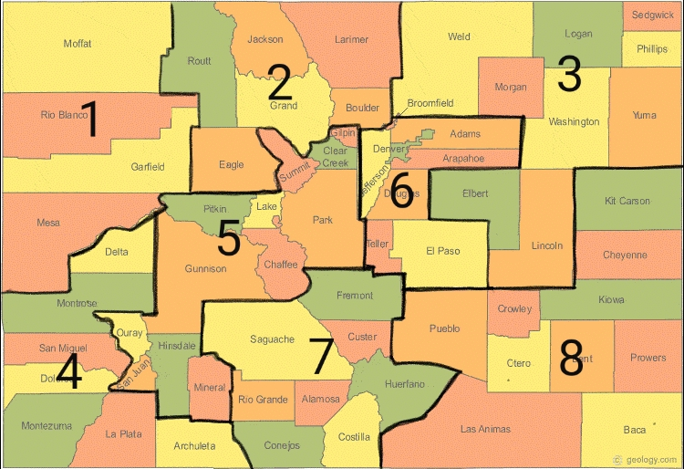

Of note in the characteristics of certain regions are the higher average elevation of district five, the large Front Range population centers in district six, and the large solar farm installations already in the San Luis Valley in district seven.

Transmission costs can play a significant part in the final costs of renewable developments. To incorporate these costs into the model transmission variables were added which were used to represent transmission from each district to all adjacent districts. In early test cases for the model without transmission costs the cheapest district produced all electricity for the whole state, and all of the other districts received their energy through transmission. To represent these costs the total amount of energy transmitted between districts is summed and a cost per kW transmitted is multiplied by this sum. Additionally efficiency terms were multiplied by the transmission variables which cause districts to produce more energy when it is transmitted to another district to account for these transmission losses.

While our costs for development for the state of Colorado from the Open PV Project were around $7,000/kW the average across the country is $2,880/kW. This disparity between data for Colorado and the nation likely caused a significant overestimate of cost for renewable energy developments.

Average costs of solar development per district varied drastically, ranging from $4,710/kW to $9,320/kW. The group assumed that the differences in costs could be addressed by normalizing the costs of development for the districts and adding these normalized values to the minimum cost. This led to much more realistic differences in cost from district to district.

**Optimization**

The model we chose to implement the optimization is a linear programming model. The objective is to minimize the cost which is a linear function subject to linear constraints. The model has non negativity constraints for generation amounts for all eight divisions and for the transmission amounts between the different divisions. Parameters are defined for demand in each division taking into consideration the internal generation and transmission. The total energy in one division must equal the demand of that district. This means that a division with low development costs could produce more energy and essentially export that to neighboring divisions. The total cost of generation is calculated by multiplying the generated electricity in a district with that district’s cost of generation per KW. The total cost of transmission is calculated by multiplying the sum of all the transmitted electricity from the districts and the transmission cost per KW. Additionally the inefficiencies for transmission, based on potential solar farm locations and their distances to neighboring divisions as well as the average seven percent losses seen earlier in Colorado, were applied to transmission variables. In the calculation of generation costs a weight is applied based on their average sunlight hours received per year. The objective function is the sum of the costs of generation and cost of transmission. The decision variables are the amounts of electricity generated in each division and the amount of electricity transmitted from one district to another. We have formulated our optimization in Excel and AMPL. In AMPL, we have used both the CPLEX and GUROBI solvers to get optimized costs.

|  |  |  |  |  |
| --- | --- | --- | --- | --- |
| Test Scenarios | Total Cost (thousands of dollars) | Transmission Cost(thousands of dollars) | Maintenance Cost(thousands of dollars) | Total Area covered ( sq miles) |
| Default with no sunlight hours | $31,048,097.87 | 0.4324 | $32,600,502.76 | 14.71 |
| With sunlight hours and distance for transmission | $103,448,522.49 | 3 | $108,620,948.61 | 49.04 |
| Changed transmission cost | $102,221,343.22 | 0.5 | $107,279,819.45 | 49.14 |
| Changed transmission cost | $101,459,802.94 | 0.15 | $106,515,117.40 | 49.29 |

The transmission cost of 2.4 thousand dollars per KW is the upper bound where energy is generated in all the divisions. Refer Appendix - D for scenarios’ generation costs.

**Results/Test Cases**

Transmission cost of 2.4 thousand dollars per KW is the upper bound where electricity is generated in all the districts. Transmission cost of 0 generates electricity in districts 1, 6 and 8. Assuming 15 miles of required transmission and taking an average of each districts energy needs , the cost of transmission is 1.65 thousand dollars per KW.

**Conclusions**

The optimization of solar panels placement proved to be a topic that quickly became very complex. As a means to combat this complexity there have been many assumptions taken to make this model functional and informative. With increasing transmission costs, distributed generation became very attractive and cost effective. Given the differences in costs from our data set the model would generate energy in the cheapest areas and transmit across the state with miniscule transmission costs. Clearly this is not a realistic scenario as interconnection to the grid and transmission can pose significant costs. As inefficiencies in generation vary by region this also affected where solar assets were deployed. The model will always pick either full generation of a district’s demands internally or get all of the demand met through a neighboring district. Once the difference in generation costs from one district to another is equal to the cost of transmission then districts will begin to produce their own solar power internally. Since the model doesn’t have any variables which represent the ease of rooftop solar installations there is no benefit for the model to produce any energy from this cheaper method which requires no transmission costs. Additionally, according to our base data, Colorado already has approximately 0.32 square miles of solar panels installed. Given the large values found for 50% of renewable energy generated from solar the state will need about 48.7 square miles of additional solar installations to meet our current energy needs.

With further developments of the model we would consider the transmission cost variations due to the kind of location we considered i.e., the transmission cost increases with low population densities. This is because the length of transmission lines to be built is higher to reach existing transmission systems into which they could connect. Additional considerations for the model in the future would be an addition of a term which allowed each division to produce energy for residential solar installations that didn’t have some associated transmission cost. Weather and the efficiencies of solar panels due to changes in weather were also not considered in this model. An addition of this to the model would drastically improve its utility.

**Appendix - A**

AMPL CODE

param CD1 = 4.71;

param CD2 = 6.71;

param CD3 = 6.25;

param CD4 = 8.1;

param CD5 = 7.15;

param CD6 = 5.55;

param CD7 = 9.32;

param CD8 = 8.27;

var G1 >= 0;

var G2 >= 0;

var G3 >= 0;

var G4 >= 0;

var G5 >= 0;

var G6 >= 0;

var G7 >= 0;

var G8 >= 0;

param DLhrs_1 = 1414.875;

param DLhrs_2 = 1297.696735;

param DLhrs_3 = 1229.694444;

param DLhrs_4 = 1454.280714;

param DLhrs_5 = 1265.668333;

param DLhrs_6 = 1303.82375;

param DLhrs_7 = 1433.835;

param DLhrs_8 = 1453.959;

var C1 = CD1 * G1;

var C2 = CD2 * G2;

var C3 = CD3 * G3;

var C4 = CD4 * G4;

var C5 = CD5 * G5;

var C6 = CD6 * G6;

var C7 = CD7 * G7;

var C8 = CD8 * G8;

param D_1 = 265031;

param D_2 = 846227;

param D_3 = 438018;

param D_4 = 202840;

param D_5 = 147260;

param D_6 = 3916296;

param D_7 = 121822;

param D_8 = 274802;

param tr_cost = 3;

var T1_2 >= 0;

var T1_4 >= 0;

var T1_5 >= 0;

var T2_1 >= 0;

var T2_3 >= 0;

var T2_5 >= 0;

var T2_6 >= 0;

var T3_2 >= 0;

var T3_6 >= 0;

var T3_8 >= 0;

var T4_1 >= 0;

var T4_5 >= 0;

var T4_7 >= 0;

var T5_1 >= 0;

var T5_2 >= 0;

var T5_4 >= 0;

var T5_6 >= 0;

var T5_7 >= 0;

var T6_2 >= 0;

var T6_3 >= 0;

var T6_5 >= 0;

var T6_7 >= 0;

var T6_8 >= 0;

var T7_4 >= 0;

var T7_5 >= 0;

var T7_6 >= 0;

var T7_8 >= 0;

var T8_3 >= 0;

var T8_6 >= 0;

var T8_7 >= 0;

param D1_2 = 16;

param D1_4 = 110;

param D1_5 = 88;

param D2_1 = 131;

param D2_3 = 4;

param D2_5 = 78;

param D2_6 = 59;

param D3_2 = 14;

param D3_6 = 3;

param D3_8 = 138;

param D4_1 = 69;

param D4_5 = 15;

param D4_7 = 82;

param D5_1 = 100;

param D5_2 = 55;

param D5_4 = 92;

param D5_6 = 45;

param D5_7 = 48;

param D6_2 = 78;

param D6_3 = 33;

param D6_5 = 75;

param D6_7 = 45;

param D6_8 = 44;

param D7_4 = 78;

param D7_5 = 54;

param D7_6 = 88;

param D7_8 = 71;

param D8_3 = 63;

param D8_6 = 25;

param D8_7 = 30;

param PL1_2 = 1 + (D1_2 * 0.0001) + 0.07;

param PL1_4 = 1 + (D1_4 * 0.0001) + 0.07;

param PL1_5 = 1 + (D1_5 * 0.0001) + 0.07;

param PL2_1 = 1 + (D2_1 * 0.0001) + 0.07;

param PL2_3 = 1 + (D2_3 * 0.0001) + 0.07;

param PL2_5 = 1 + (D2_5 * 0.0001) + 0.07;

param PL2_6 = 1 + (D2_6 * 0.0001) + 0.07;

param PL3_2 = 1 + (D3_2 * 0.0001) + 0.07;

param PL3_6 = 1 + (D3_6 * 0.0001) + 0.07;

param PL3_8 = 1 + (D3_8 * 0.0001) + 0.07;

param PL4_1 = 1 + (D4_1 * 0.0001) + 0.07;

param PL4_5 = 1 + (D4_5 * 0.0001) + 0.07;

param PL4_7 = 1 + (D4_7 * 0.0001) + 0.07;

param PL5_1 = 1 + (D5_1 * 0.0001) + 0.07;

param PL5_2 = 1 + (D5_2 * 0.0001) + 0.07;

param PL5_4 = 1 + (D5_4 * 0.0001) + 0.07;

param PL5_6 = 1 + (D5_6 * 0.0001) + 0.07;

param PL5_7 = 1 + (D5_7 * 0.0001) + 0.07;

param PL6_2 = 1 + (D6_2 * 0.0001) + 0.07;

param PL6_3 = 1 + (D6_3 * 0.0001) + 0.07;

param PL6_5 = 1 + (D6_5 * 0.0001) + 0.07;

param PL6_7 = 1 + (D6_7 * 0.0001) + 0.07;

param PL6_8 = 1 + (D6_8 * 0.0001) + 0.07;

param PL7_4 = 1 + (D7_4 * 0.0001) + 0.07;

param PL7_5 = 1 + (D7_5 * 0.0001) + 0.07;

param PL7_6 = 1 + (D7_6 * 0.0001) + 0.07;

param PL7_8 = 1 + (D7_8 * 0.0001) + 0.07;

param PL8_3 = 1 + (D8_3 * 0.0001) + 0.07;

param PL8_6 = 1 + (D8_6 * 0.0001) + 0.07;

param PL8_7 = 1 + (D8_7 * 0.0001) + 0.07;

var Trans_sum = T1_2 + T1_4 + T1_5 + T2_1 + T2_3 + T2_5 + T2_6 + T3_2 + T3_6 + T3_8 + T4_1 + T4_5 + T4_7 + T5_1 + T5_2 + T5_4 + T5_6 + T5_7 + T6_2 + T6_3 + T6_5 + T6_7 + T6_8 + T7_4 + T7_5 +T7_6 + T7_8 + T8_3 + T8_6 + T8_7;

var Trans_cost = tr_cost * Trans_sum;

Minimize cost:

C1 + C2 + C3 + C4 + C5 + C6 + C7 + C8 + Trans_cost;

subject to ct1: ((G1 * 4380) / DLhrs_1 ) + T1_2 + T1_4 + T1_5 - (T2_1 * PL2_1) - (T4_1 * PL4_1) - (T5_1 * PL5_1) = D_1;

subject to ct2: ((G2 * 4380) / DLhrs_2 ) + T2_1 + T2_3 + T2_5 + T2_6 - (T1_2 * PL1_2) - (T3_2 * PL3_2) - (T5_2 * PL5_2) - (T6_2 * PL6_2) = D_2;

subject to ct3: ((G3 * 4380) / DLhrs_3 ) + T3_2 + T3_6 + T3_8 - (T2_3 * PL2_3) - (T6_3 * PL6_3) - (T8_3 * PL8_3) = D_3;

subject to ct4: ((G4 * 4380) / DLhrs_4 ) + T4_1 + T4_5 + T4_7 - (T1_4 * PL1_4) - (T5_4 * PL5_4) - (T7_4 * PL7_4) = D_4;

subject to ct5: ((G5 * 4380) / DLhrs_5 ) + T5_1 + T5_2 + T5_4 + T5_6 + T5_7 - (T1_5 * PL1_5) - (T2_5 * PL2_5) - (T4_5 * PL4_5) - (T6_5 * PL6_5) - (T7_5 * PL7_5) = D_5;

subject to ct6: ((G6 * 4380) / DLhrs_6 ) + T6_2 + T6_3 + T6_5 + T6_7 + T6_8 - (T2_6 * PL2_6) - (T3_6 * PL3_6) - (T5_6 * PL5_6) - (T7_6 * PL7_6) - (T8_6 * PL8_6) = D_6;

subject to ct7: ((G7 * 4380) / DLhrs_7 ) + T7_4 + T7_5 + T7_6 + T7_8 - (T4_7 * PL4_7) - (T5_7 * PL5_7) - (T6_7 * PL6_7) - (T8_7 * PL8_7) = D_7;

subject to ct8: ((G8 * 4380) / DLhrs_8 ) + T8_3 + T8_6 + T8_7 - (T3_8 * PL3_8) - (T6_8 * PL6_8) - (T7_8 * PL7_8) = D_8;

**Steps to run:**

1. model solar.mod;
2. option solver cplex;
3. solve;
4. display C1,C2,C3,C4,C5,C6,C7,C8;
5. display G1,G2,G3,G4,G5,G6,G7,G8;
6. display T1_2,T1_4,T1_5,T2_1,T2_3, T2_5, T2_6, T3_2, T3_6, T3_8, T4_1, T4_5, T4_7, T5_1, T5_2, T5_4, T5_6, T5_7, T6_2, T6_3, T6_5, T6_7, T6_8, T7_4, T7_5, T7_6, T7_8, T8_3, T8_6, T8_7;
7. Use command “reset” to clear the previous commands

**Appendix - B**

County Breakdown

District 1: Moffat, Rio Blanco, Mesa, and Garfield

District 2: Routt, Jackson, Larimer, Grand, Eagle, and Boulder

District 3: Weld, Logan, Sedgwick, Morgan, Washington, Yuma, Elbert, Lincoln, and Phillips

District 4: Delta, Montrose, San Miguel, Dolores, Montezuma, La Plata, and Archuleta

District 5: Ouray, San Juan, Hinsdale, Mineral, Gunnison, Pitkin, Lake, Summit, Chaffee, Park, Clear Creek, and Gilpin

District 6: Jefferson, Broomfield, Adams, Denver, Arapahoe, Douglas, Teller, and El Paso

District 7: Saguache, Fremont, Custer, Huerfano, Alamosa, Rio Grande, Conejos, and Costilla District 8: Kit Carson, Cheyenne, Kiowa, Pueblo, Crowley, Otero, Bent, Prowers, Las Animas, and Baca

**Appendix - C**

Average Electricity Losses By State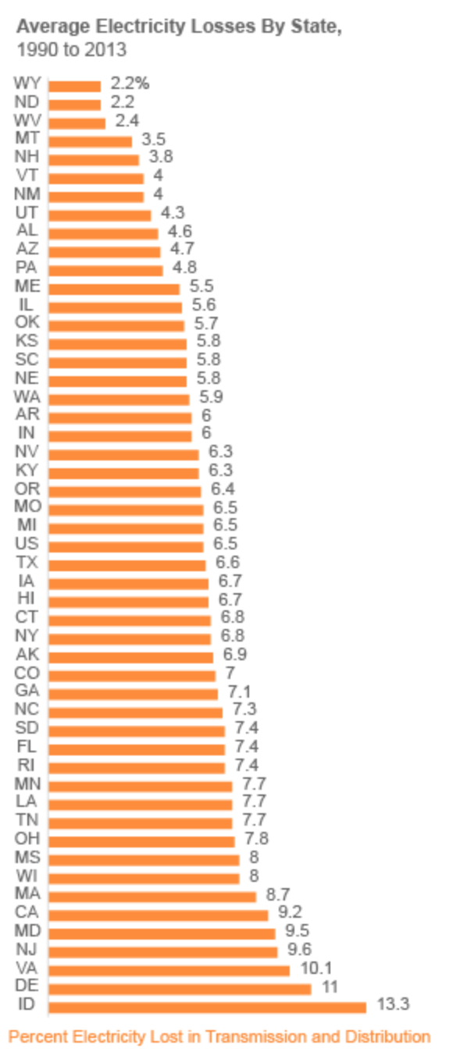

**Appendix - D**

Costs of Generation for Scenarios

Default Scenario :

|  |  |  |
| --- | --- | --- |
|  | Cost of Generation (Thousands $) |  |
| C1 | $ 1,248,296.01 | $ 1,310,710.81 |
| C2 | $ 4,352,855.85 | $ 4,570,498.64 |
| C3 | $ 2,209,387.50 | $ 2,319,856.87 |
| C4 | $ 1,104,536.40 | $ 1,159,763.22 |
| C5 | $ 771,536.99 | $ 810,113.84 |
| C6 | $ 19,159,352.56 | $ 20,117,320.19 |
| C7 | $ 695,603.62 | $ 730,383.80 |
| C8 | $ 1,506,528.94 | $ 1,581,855.39 |
| Total Cost of Generation (Thousands $) | $ 31,048,097.87 |  |
| Cost of Transmission (Thousands $) | $ - |  |
|  |  |  |
|  | Total Cost (Thousands $) | 5 Year Cost with Maintenance |
|  | $ 31,048,097.87 | $ 32,600,502.76 |

Scenario : With sunlight hours and distance for transmission with transmission cost ( Thousand dollars per KW ) = 0.5

|  |  |
| --- | --- |
|  | **Cost of Generation (Thousands $)** |
| **C1** | **$ 32,204,957.56** |
| **C2** | **$ -** |
| **C3** | **$ -** |
| **C4** | **$ -** |
| **C5** | **$ -** |
| **C6** | **$ 64,362,966.41** |
| **C7** | **$ -** |
| **C8** | **$ 4,538,365.09** |

Scenario : With sunlight hours and distance for transmission with transmission cost ( Thousand dollars per KW ) = 0.

|  |  |
| --- | --- |
|  | **Cost of Generation (Thousands $)** |
| **C1** | **$ 32,204,957.56** |
| **C2** | **$ -** |
| **C3** | **$ -** |
| **C4** | **$ -** |
| **C5** | **$ -** |
| **C6** | **$ 64,362,966.41** |
| **C7** | **$ -** |
| **C8** | **$ 4,538,365.09** |

**References:**

1. Marsh, J. (2018, October 01). 250-Watt Solar Panels: Are They Right for You? | EnergySage. Retrieved December 3, 2018, from <https://news.energysage.com/250-watt-solar-panels-are-they-right-for-you/>
2. NREL Data Analysis and Visualization Group. (n.d.). The Open PV Project. Retrieved December 3, 2018, from https://openpv.nrel.gov/
3. Electric power transmission. (2018, November 26). Retrieved December 3, 2018, from <https://en.wikipedia.org/wiki/Electric_power_transmission>
4. Underground vs. Overhead: Power Line Installation-Cost Comparison and Mitigation. (2013, February 01). Retrieved December 3, 2018, from <https://www.elp.com/articles/powergrid_international/print/volume-18/issue-2/features/underground-vs-overhead-power-line-installation-cost-comparison-.html>
5. Wirfs-Brock, J. (2017, June 14). Lost In Transmission: How Much Electricity Disappears Between A Power Plant And Your Plug? Retrieved December 3, 2018, from <http://insideenergy.org/2015/11/06/lost-in-transmission-how-much-electricity-disappears-between-a-power-plant-and-your-plug/>
6. Solar Sunlight Hours in Colorado. (n.d.). Retrieved December 3, 2018, from <http://www.longtermsolar.com/solar-sunlight-hours-in-colorado/>
7. NREL. (n.d.). New Best-Practices Guide for Photovoltaic System Operations and Maintenance. Retrieved December 3, 2018, from <https://www.nrel.gov/docs/fy17osti/68281.pdf>
8. U.S. ZIP Codes: Free ZIP code map and zip code lookup. (n.d.). Retrieved December 3, 2018, from <https://www.unitedstateszipcodes.org/>